(Approx. 581 words)

How to Retrieve Individual Files from a Windows Backup
By David Kretchmar, Computer Hardware Technician, Sun City Summerlin Computer Club, NV
August 2017 issue, Gigabyte Gazette
http://www.scscc.club

In Windows 10, Microsoft has included the old Backup and Restore feature from Windows 7. This was weakened in Windows 8 and completely removed in Windows 8.1, but it is back in Windows 10, even if it is a bit depreciated

It’s now called “Backup and Restore (Windows7)”. Microsoft’s File History is a is a great tool designed to back up your individual files, and Microsoft seems to be pushing users to utilize this feature, rather than relying on entire system backups. To this end, Microsoft states that you cannot restore individual files from a system image.

Microsoft is being untruthful when it states that you cannot restore individual files from a system image. This might represent a twist on the old joke that when you get information from Microsoft it is completely accurate, but useless. I’m not sure it is an improvement for Microsoft to provide inaccurate information to push users to utilize File History. Using File History to back up your data fits more neatly into Microsoft’s long-term strategy of moving users to The Cloud, and maybe that’s how they justify this mendacity

Create an image then use Disk Manager
Obviously, you must create a Windows system backup before you can pull individual files from the backup image. This can be accomplished in different ways; one way is to go into the Control Panel (Category View), System Security, then Backup and Restore (Windows 7).

Once you have created the image, execute Disk Management by right clicking on the Start window and left clicking on Disk Management.
Click on Action then select “Attach VHD” (Virtual Hard Drive). Note this window Shows physical hard drives (Disk 0, Disk 1, etc.) as well as logical
drives (C:, D:, etc.).

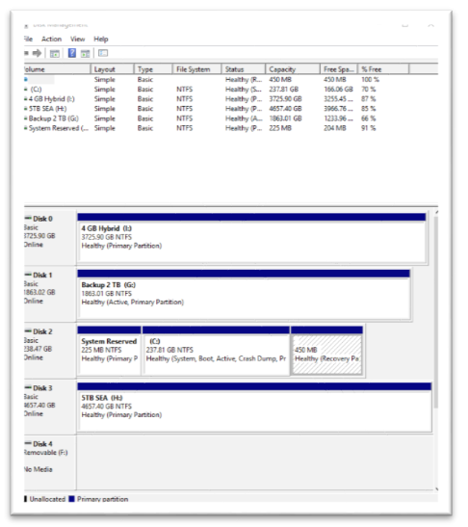
Now browse to the location of you image. Your image is contained in a folder named WindowsImageBackup. Drill down to your image file. There is more than one file in a folder named “Backup (date of backup).” The one ginormous file is the one we want to attach.

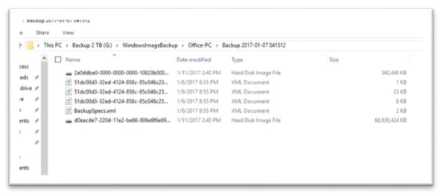

Go back to the Disk Management window and you will see a new hard drive (the virtual drive you just created). Note it is the same size as the C: drive that was imaged. Right click on the representation of this drive and proceed to add a logical drive letter to this drive, if one is not already assigned.

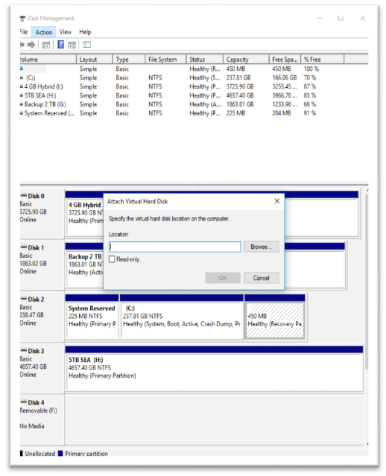

Copy your files
Now use File Explorer to access any of your files in the virtual drive you have just created. It’s that simple! You can copy and paste any files you like from the image to any other location you can access. This is not as simple as a restore from File Backup, but it works.

Remember, you have created a virtual drive, also known as a logical drive, every bit as “real” as your own C: drive, lacking only the graphical user interface. You can even execute programs on your virtual drive, if you can locate its executable or application file.

Clean up
When you are done gleaning the data you want from the virtual drive, Right
click on its representation in the Disk Management window, and delete the partition(s). Do not delete the image file on your backup drive or it will be gone forever.

Just reboot and your system will be back minus the virtualization.

